HOW TO INSTALL SELECTORSHUB AND USE IT?

Navigate to <https://www.selectorshub.com/>

1. Click on the download link for whichever browser you want.



2) Click on Add to Chrome.

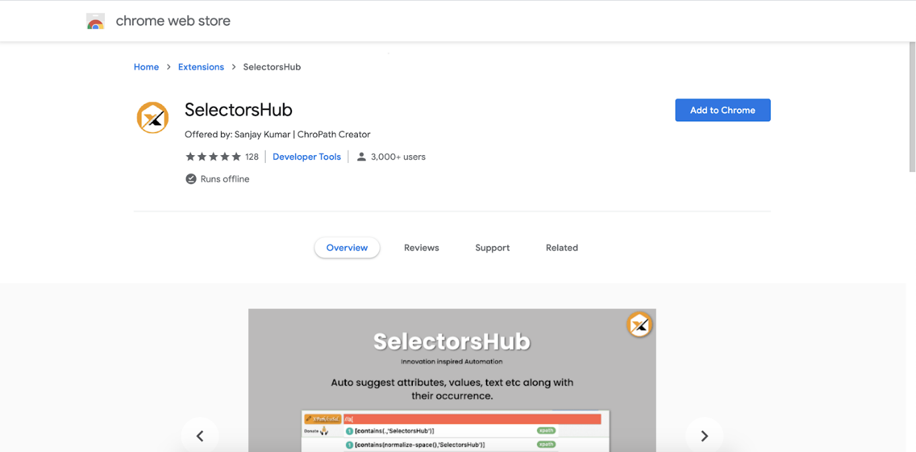

3) After adding the extension, it will show in the browser toolbar like this. You can pin to the toolbar by clicking on the pin icon.

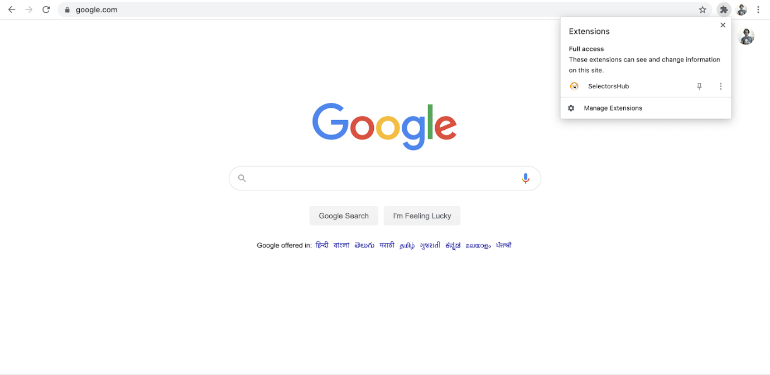

4) After adding the extension, restart the browser.

5) Now open DevTools by right clicking on any element and clicking on inspect.

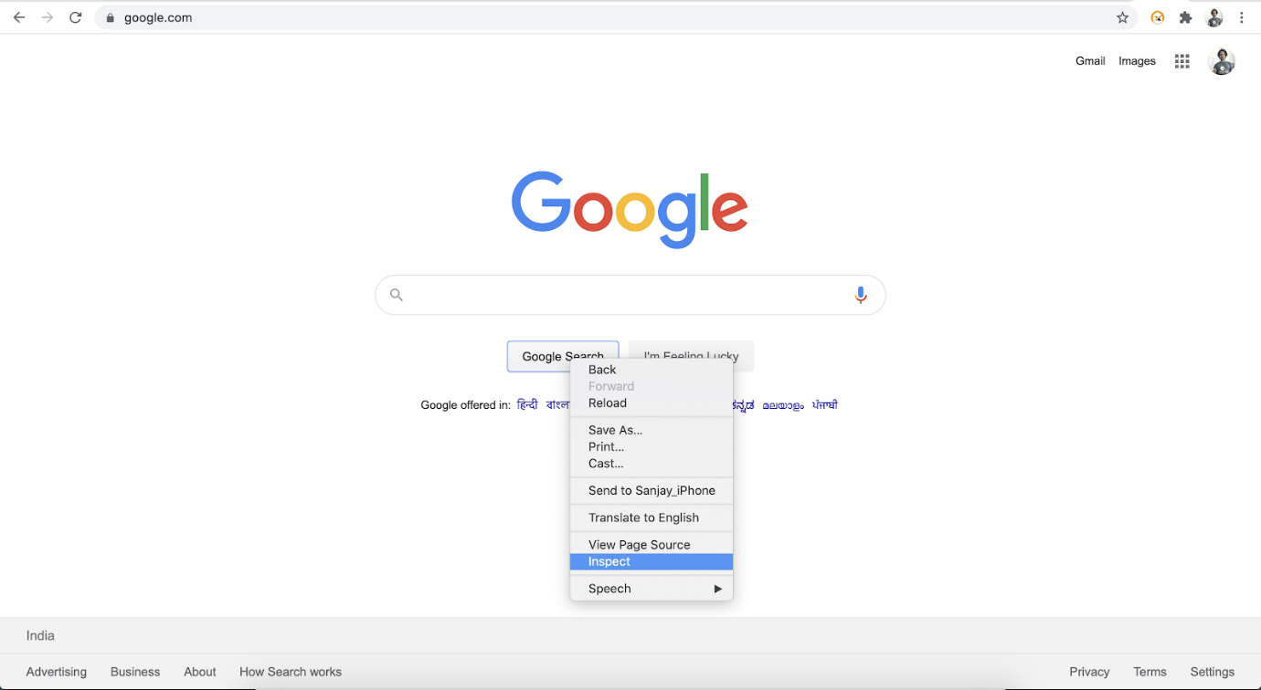

6) On the right side of the Elements tab, SelectorsHub will be the last tab as shown in below image. If not visible, expand the sidebar or click on the two arrow icons as shown in below gif.



7) Now here you start typing your xpath or cssSelector. You will get auto suggest for inspected element.

